Tutorial Migrate SQL Server to Azure SQL Database (offline)

Login to Azure Portal with provided Username
Example: LabuserXX@Azappsqltrainoutlook.onmicrosoft.com
Step1: Create SQL logical servers
Step 2: Create SQL Database
Step 3: Azure SQL Database Offline Migration

Step1: Create SQL logical servers
Login to Azure Portal with provided Username
Example: LabuserXX@Azappsqltrainoutlook.onmicrosoft.com

Search for Azure SQL databases
Go to SQL logical servers
Click on Create:
Select Subscription: Azappsqltrain subscription 1
Resource group: Labuser02-RG
Example: LabuserXX-RG
Server name: targetserverdb02
Example: targetserverdbXX
Location: (US) West US 2

Authentication method: Use both SQL and Microsoft Entra authentication
Server admin login: labuserdbXX
Password: M@rchsql@2026
Important Note : Remember the user name and password

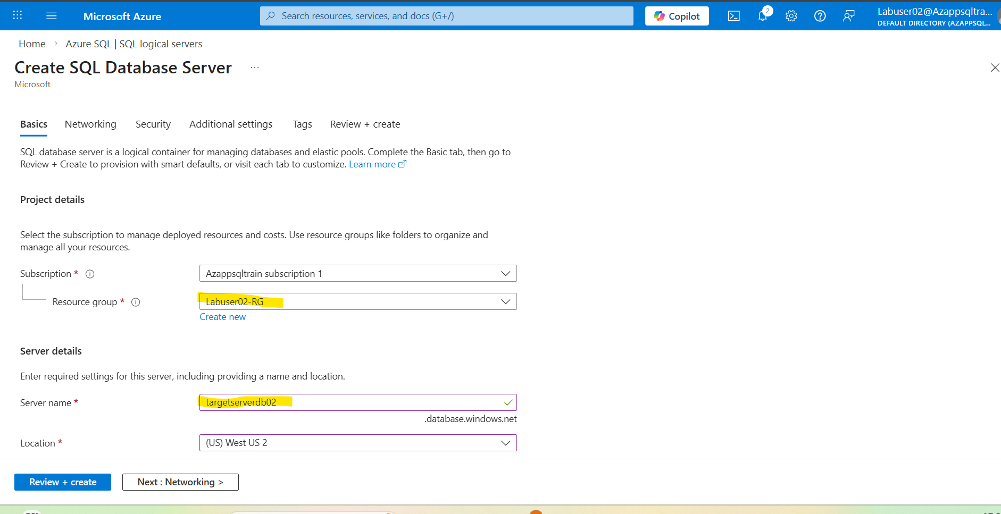
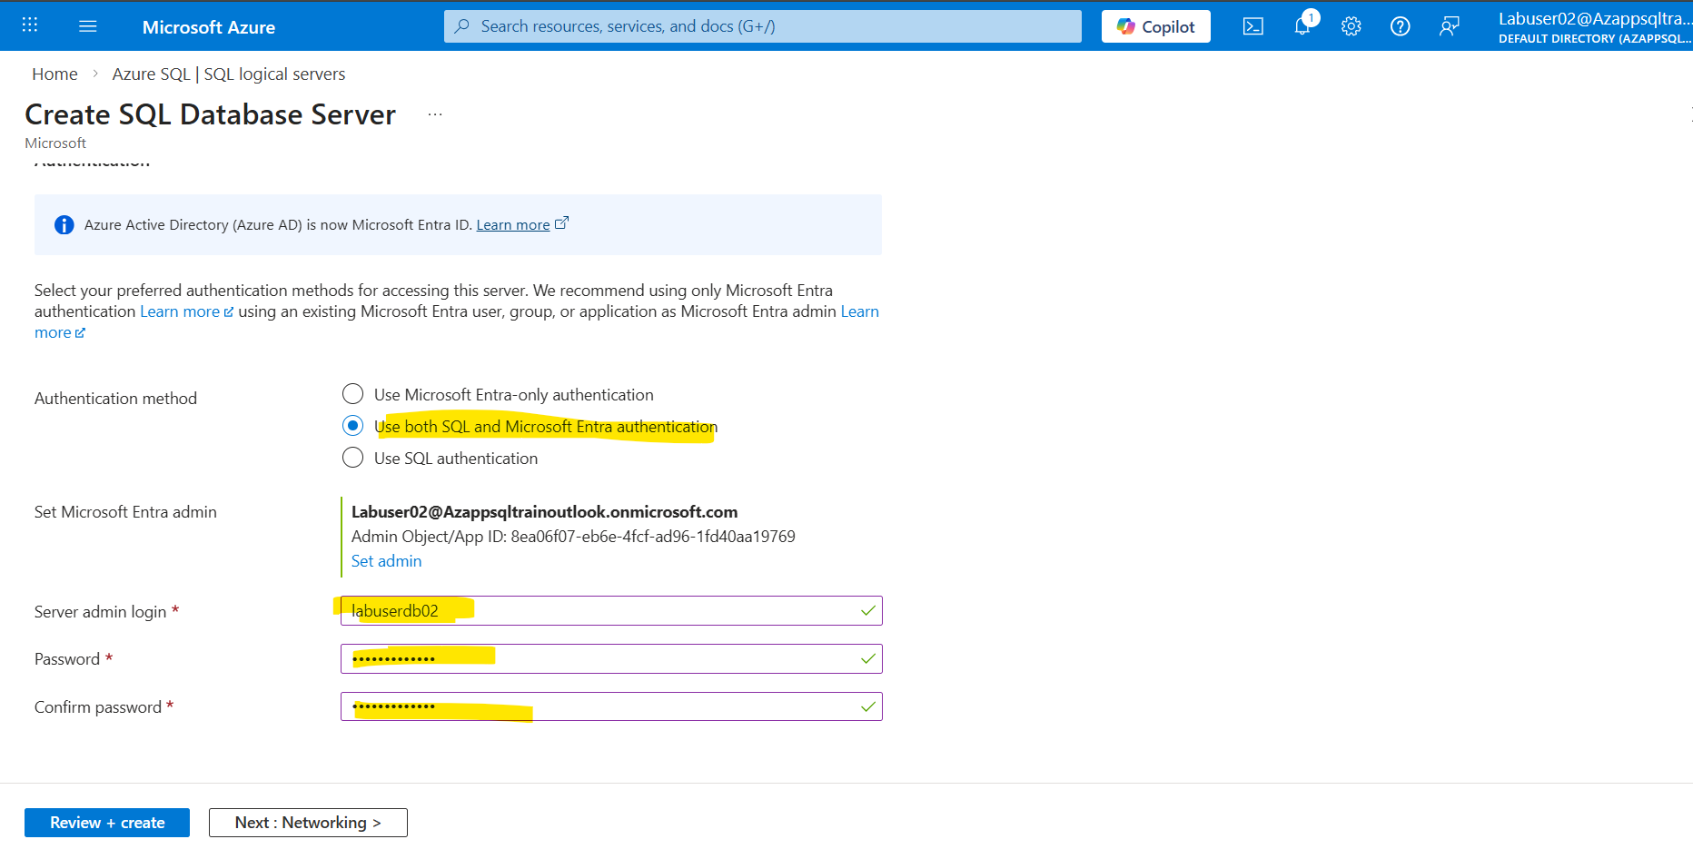
Click on create
Click Go to Resource and verify
You can see the SQL logical server created

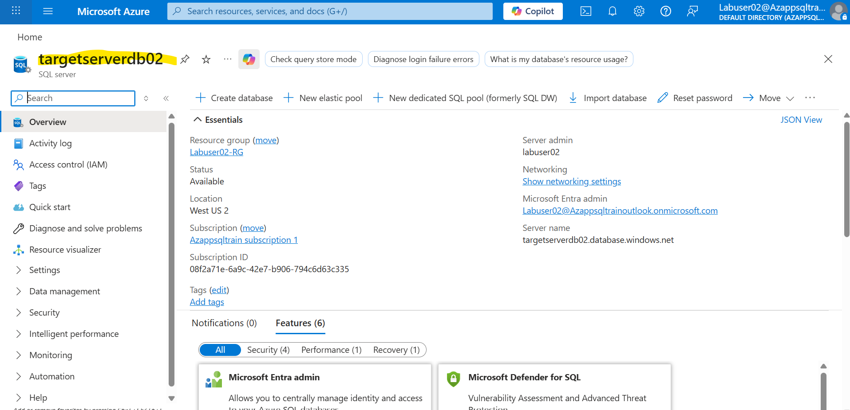
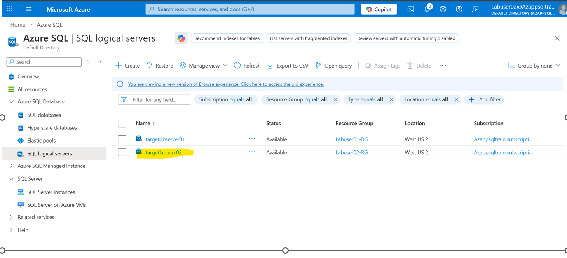

Step 2: Create SQL Database
Go to SQL databases
Click on Create
Select Subscription: Azappsqltrain subscription 1
Resource group: Labuser02-RG
Database name: targetlabuser02db
Server: Drop down and select the one you created in previous steps
Backup storage redundancy: Locally redundant backup storage

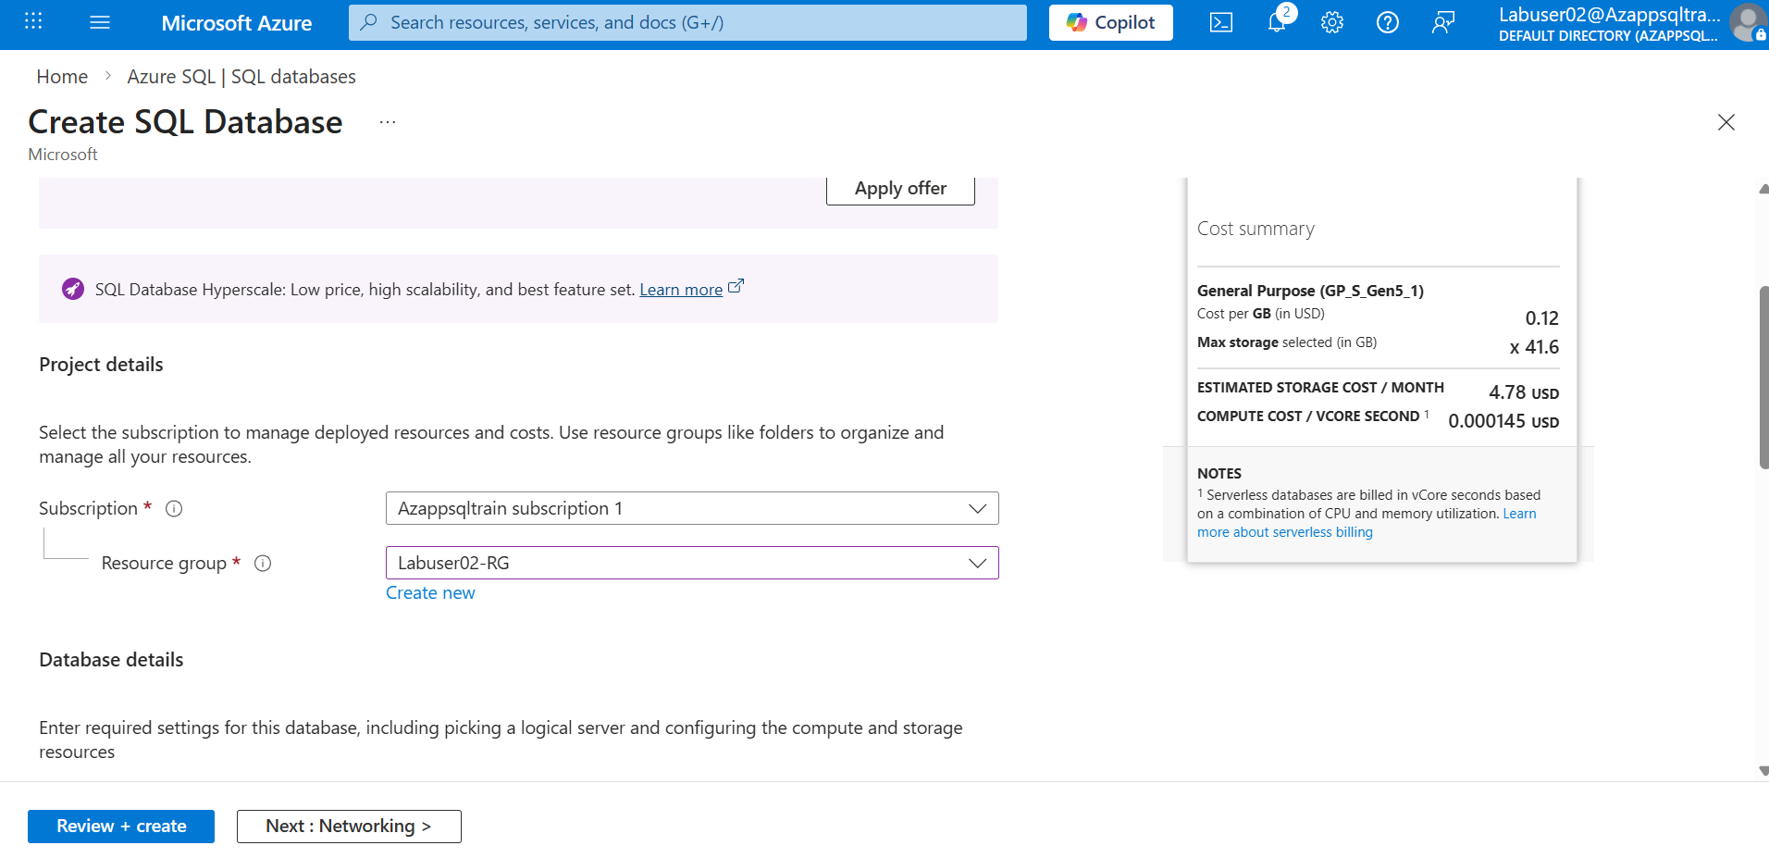

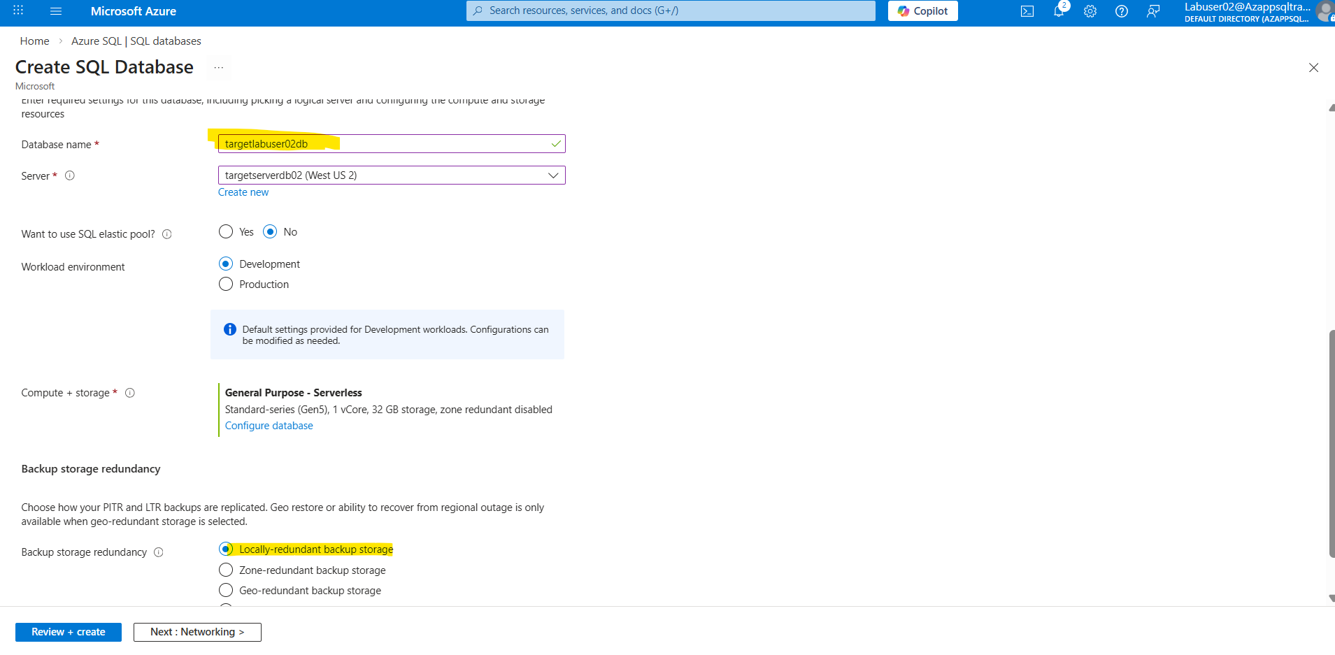

Click Next Select Add current Client Ip address: Yes
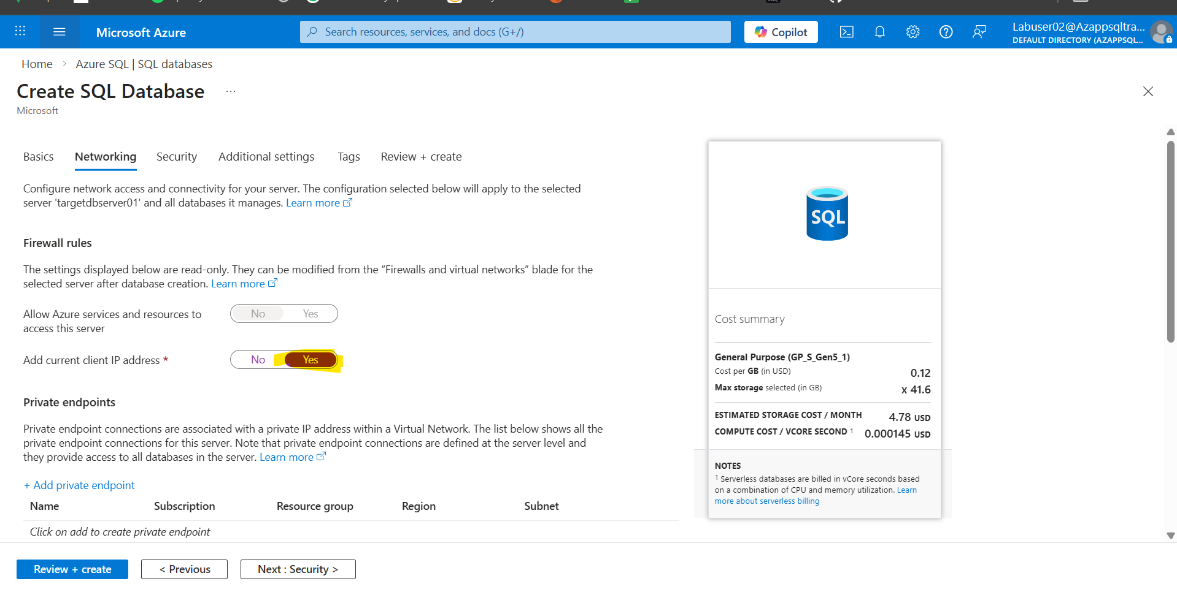

Enable Microsoft Defender for SQL select Not now
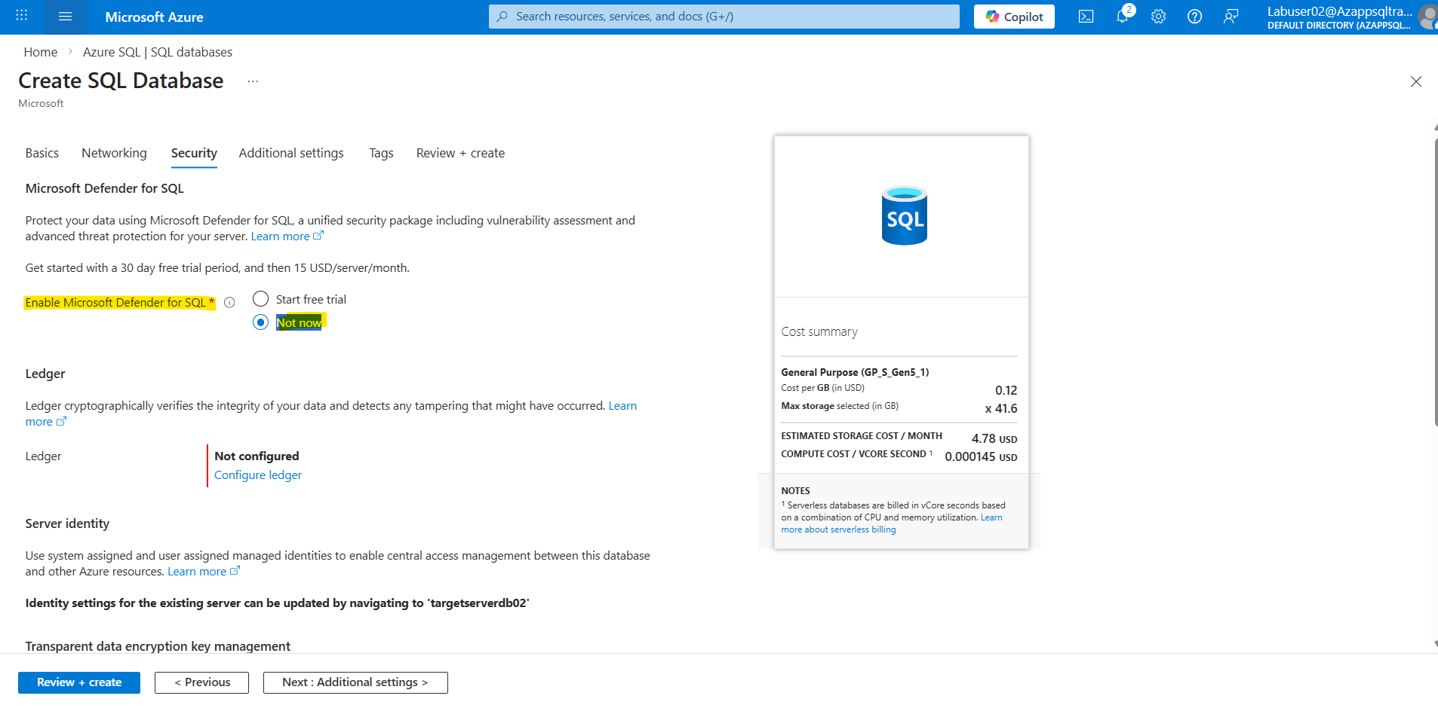
Review Create
Go to Resource
Click on Set server firewall
Public network access select Selected networks

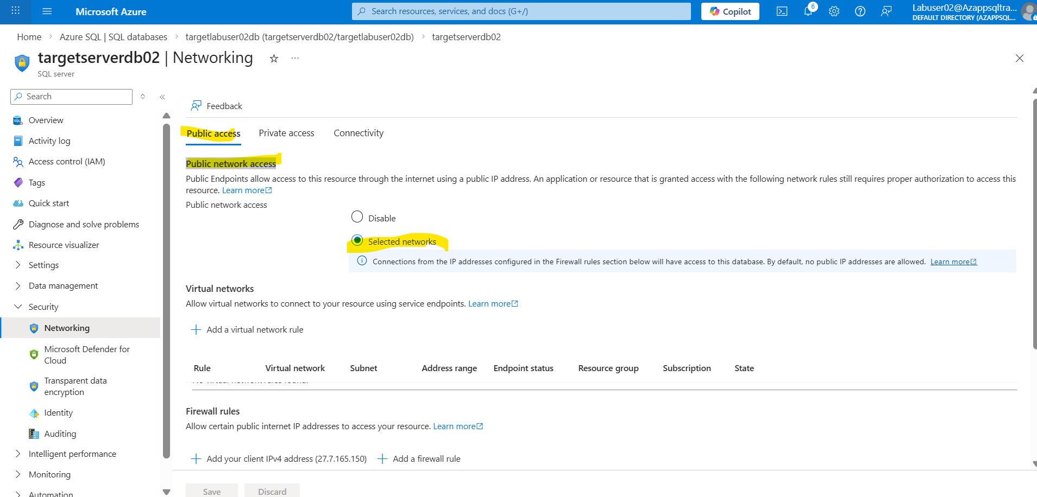

Click on Add your client IPv4 address rule
User IP address: 27.7.165.150
Click on Add a Firewall rule
Mention Rule name Start IP End IP
User IP address: 27.7.165.150
Select: Allow Azure services and resources to access this server
Save

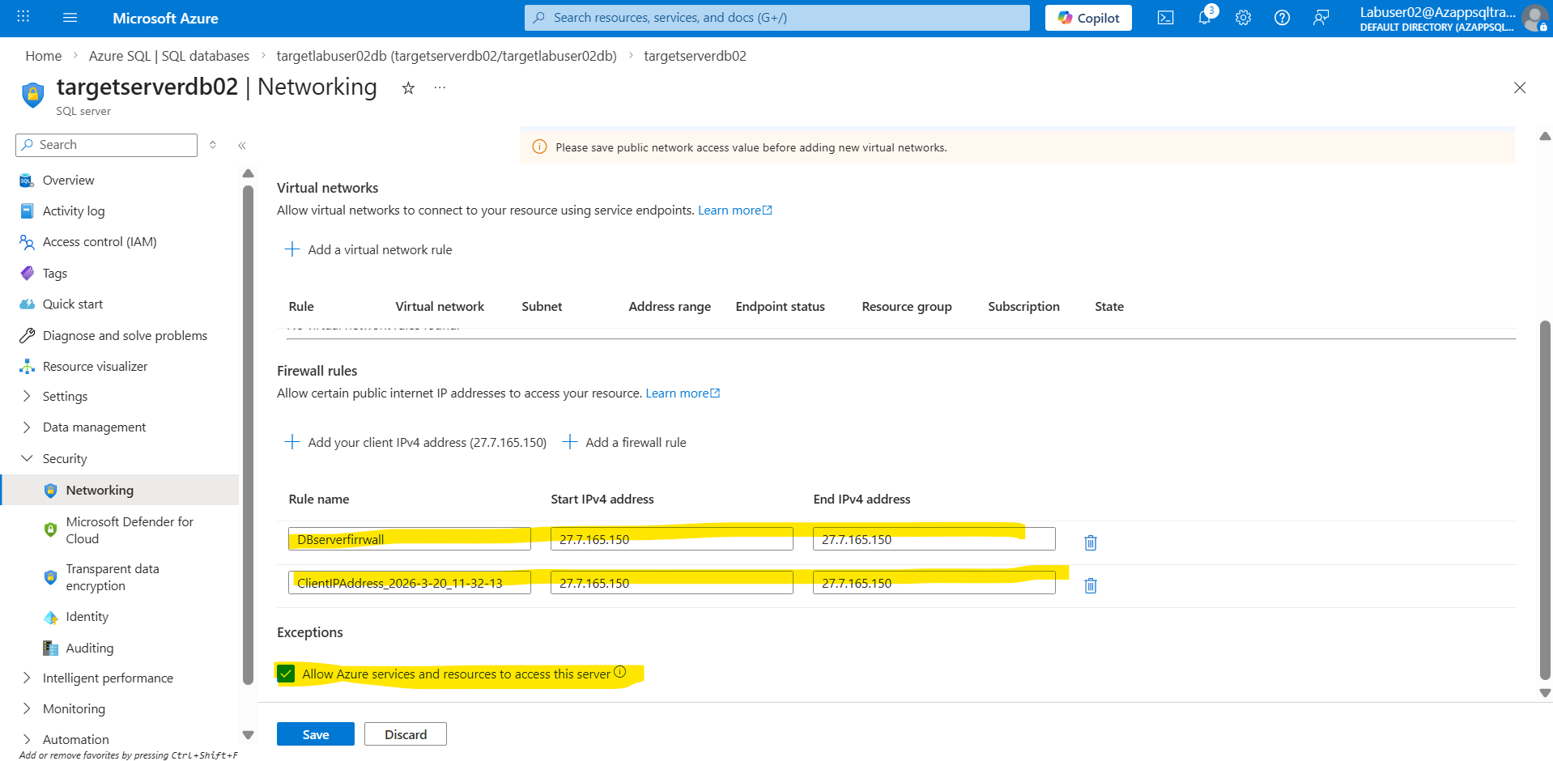

Step 3: Azure SQL Database Offline Migration
Go and search for Azure Database Migration Service
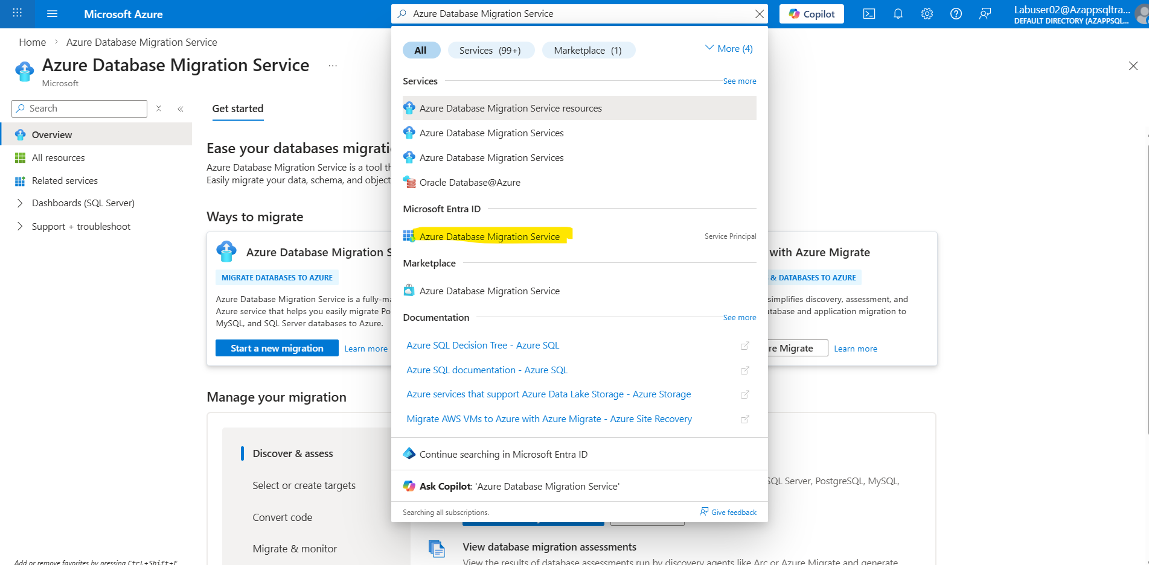
Select All resources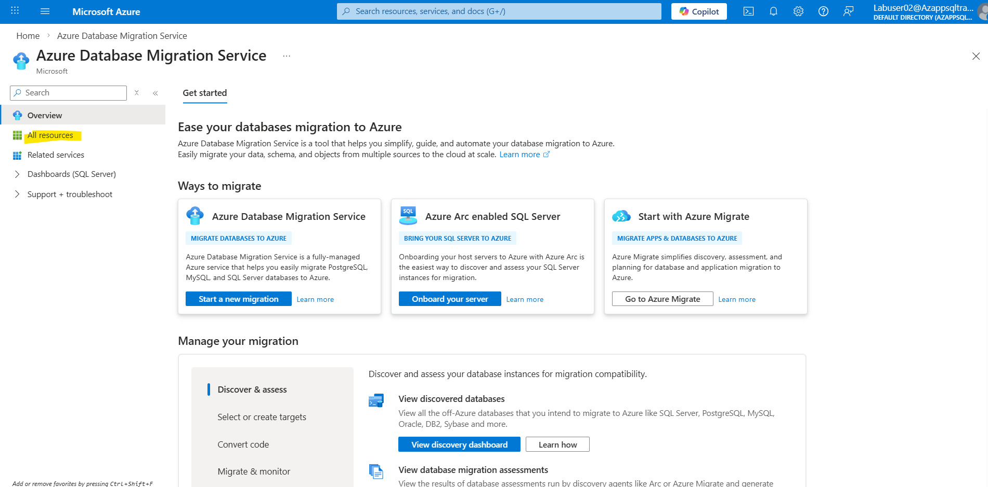
Click on Sqlmigrate
Select: Start migrations Migrate SQL Server databases to Azure SQL
Click on New Migration
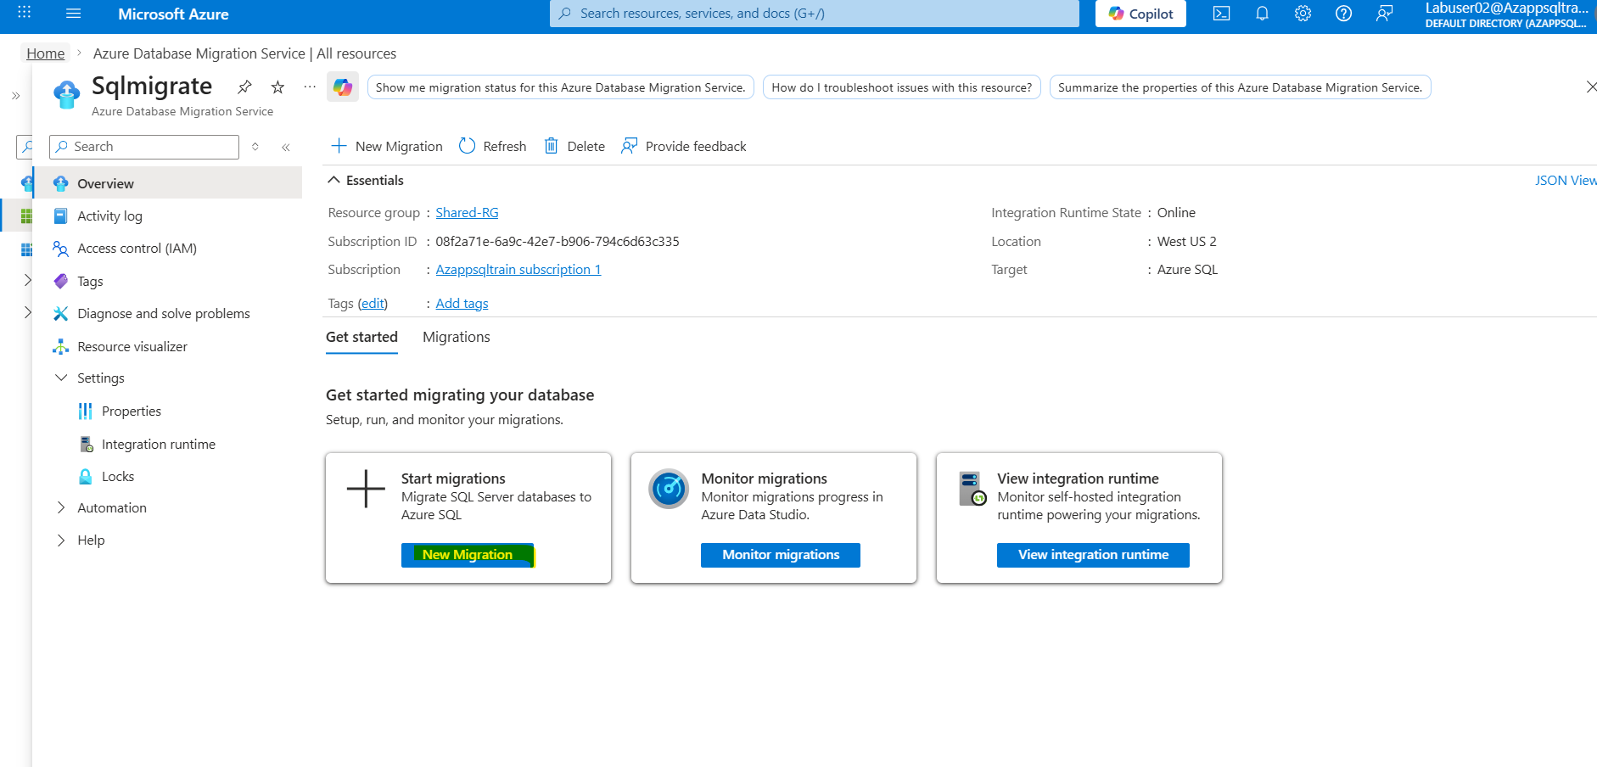
Source server type: SQL Server
Target server type: Azure SQL Database
Migration mode: Offline
Click on Select
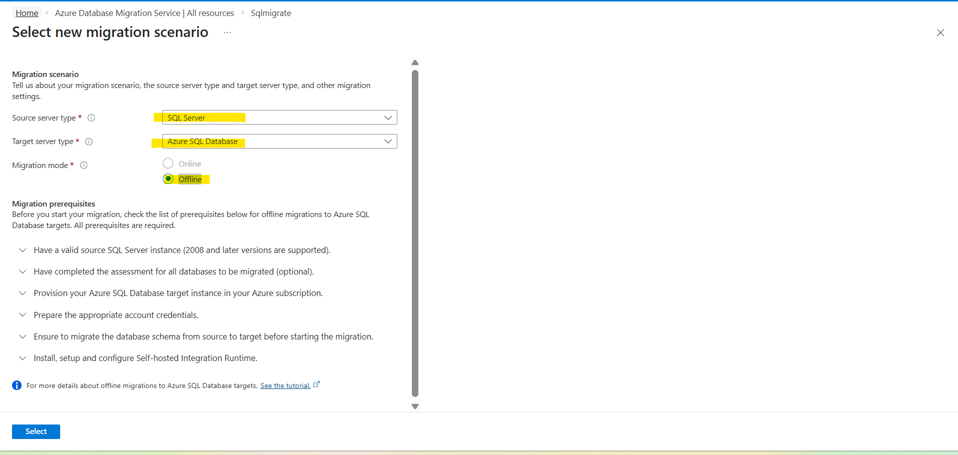

Source Infrastructure Type: Drop down and select Virtual Machine
Subscription: Azappsqltrain subscription 1
Resource group: Labuser02-RG
Location: West US 2
SQL Server Instance Name: vmsql
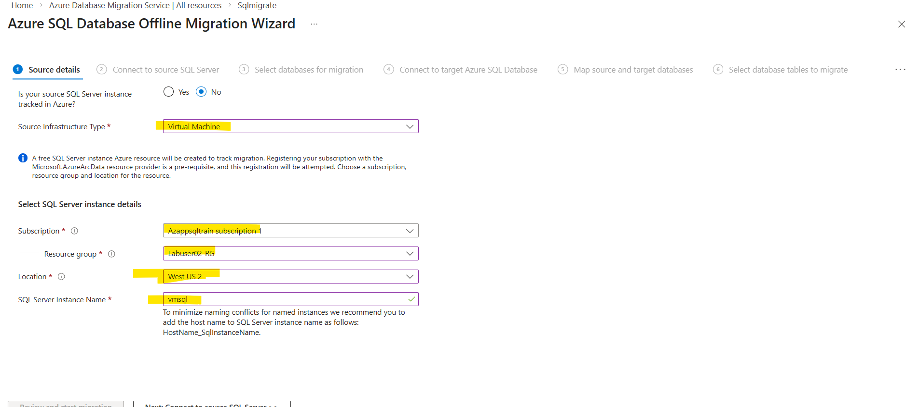

Click Next
Source server name: vmsql
Authentication type: SQL Authentication
User name: DBadmin
Password: M@rchsql@2026 (Use this password)
Connection properties: Select Trust server certificate

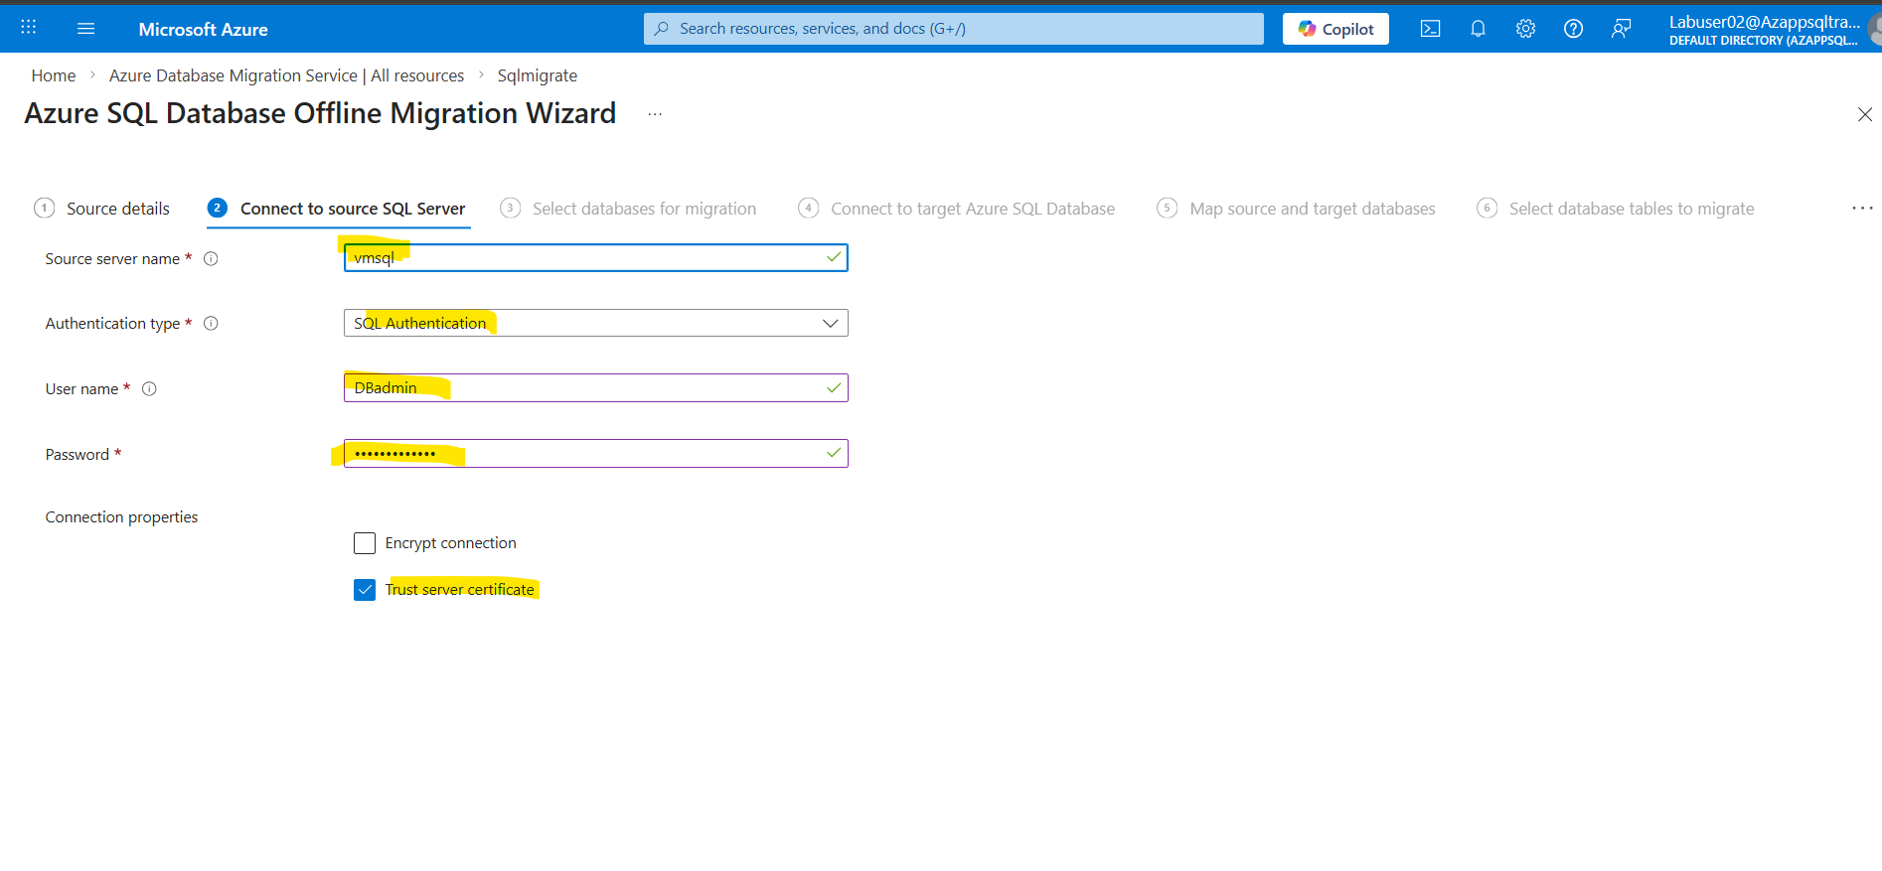
Click Next: Select Database name
Note : Select the database with respect to your username (DONOT OTHER DATABASE)
Example: LabuserXX@Azappsqltrainoutlook.onmicrosoft.com Use Database: LabuserXX
if your username is Labuser06@Azappsqltrainoutlook.onmicrosoft.com Use Database: Labuser05
f your username is Labuser06@Azappsqltrainoutlook.onmicrosoft.com Use Database: Labuser06

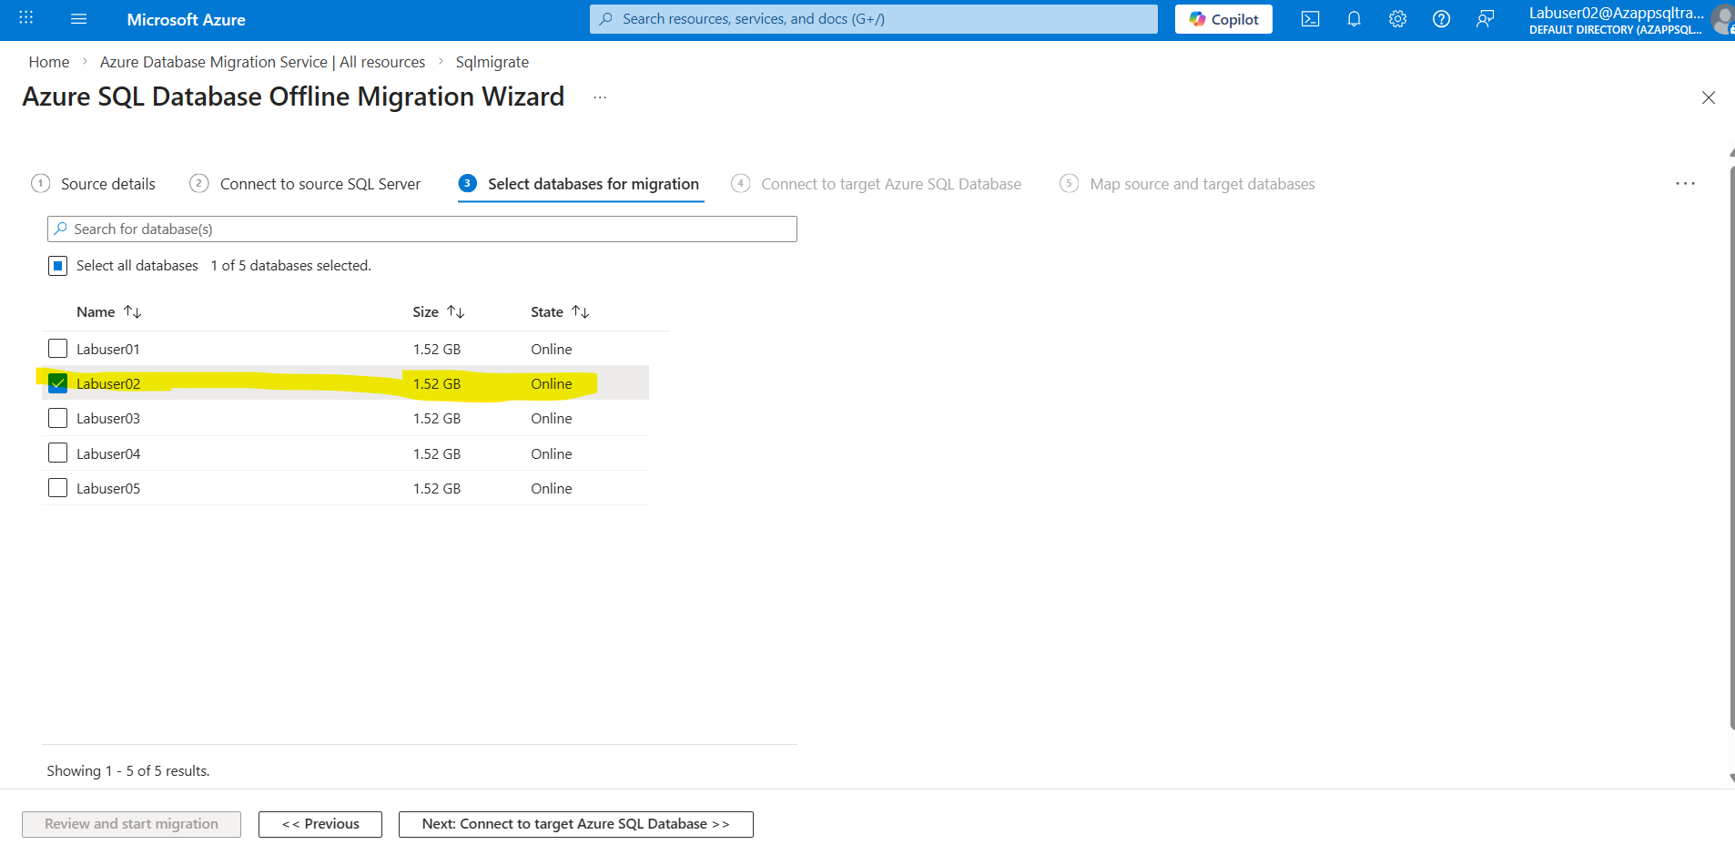
Click Next

Subscription: Azappsqltrain subscription 1
Resource group: Labuser02-RG
Target Azure SQL Database Server: targetserverdb02
Target server name: targetserverdb02.database.windows.net
Authentication type: SQL Authentication
User name: labuser02
Password: M@rchsql@2026
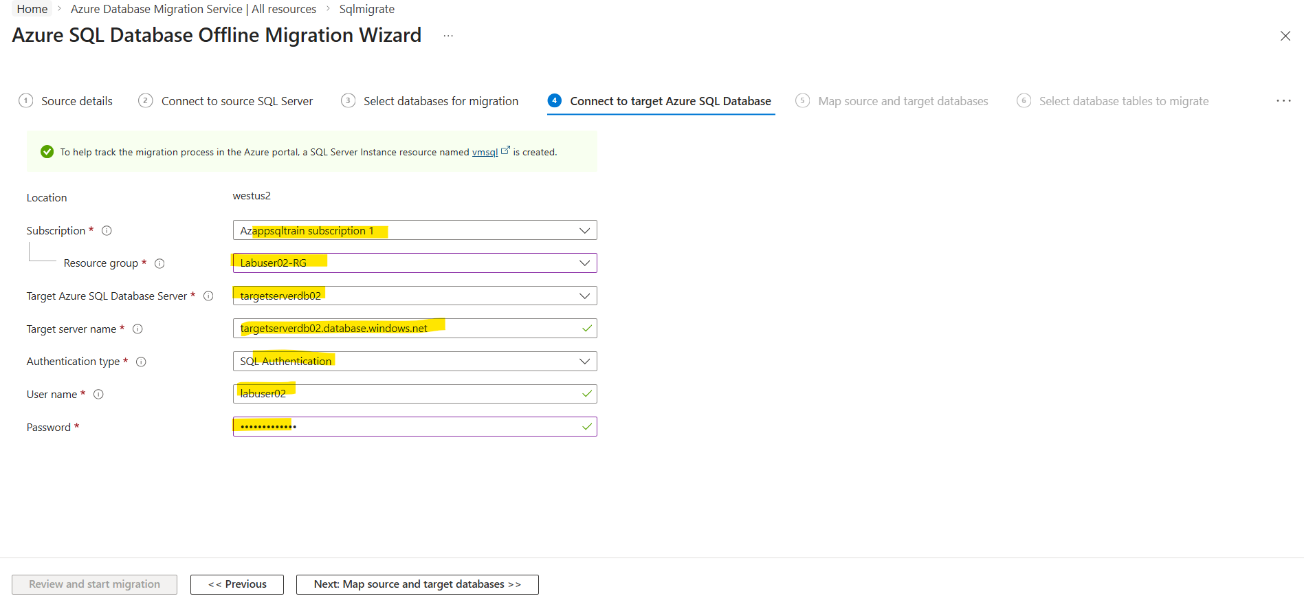
Click next :
Source database: Dropdown and select Target database targetlabuser02db

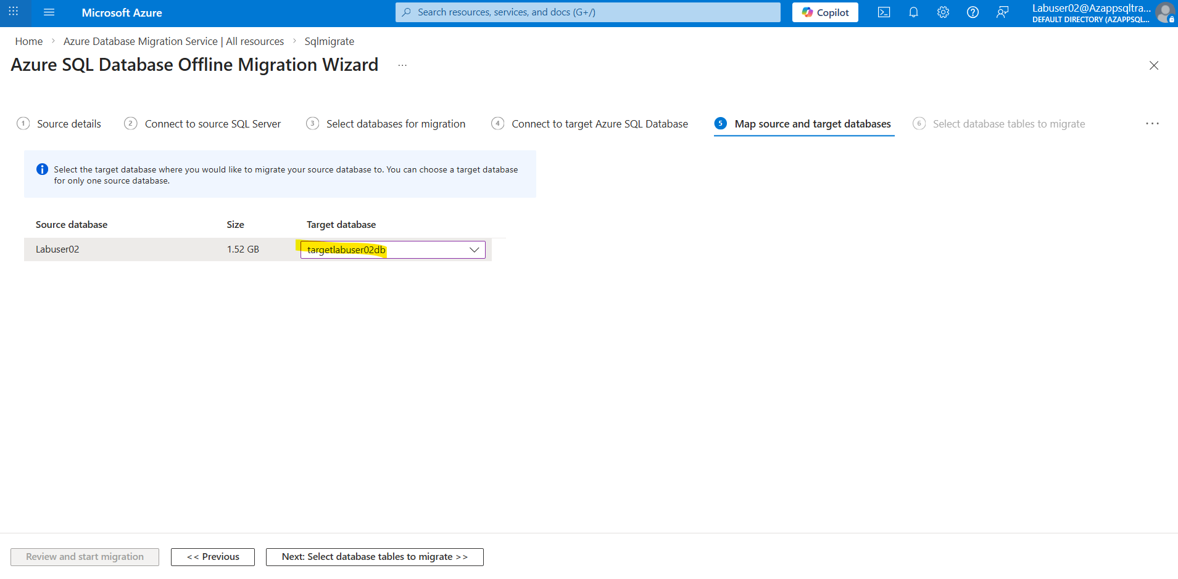
Click next
Click on Database migration summary
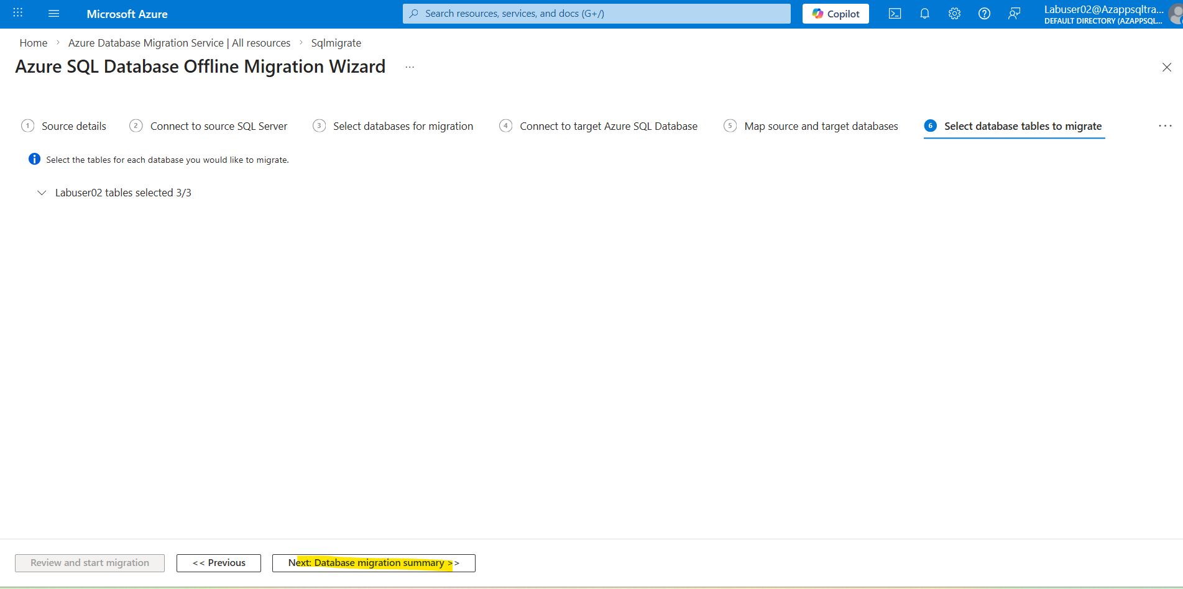
Click : start Migration
